Narrative Annual Report: The purpose of this Annual Report is to briefly elaborate on the SNAP-Ed activities and outcomes already reported through the Program Education and Reporting System (PEARS) and evaluation tools implemented during the previous fiscal year (October 1, 2019-September 30, 2020). It also requests some specific information needed for the CalFresh Healthy Living, UC’s annual report to the California Department of Social Services (CDSS) and US Department of Agriculture (USDA).

# CalFresh Healthy Living, UC Program Overview

For FFY2020, please describe program highlights in bulleted points. In your description, incorporate the FFY2020 PEARS year-end summary program data and evaluation results provided to your County/Cluster program by the State Office as appropriate. Highlights from evaluation results can be bulleted out separately or integrated into program-related bulleted summaries.

**Suggested maximum length: 1,500 words** (approximately 3.5 pages single space with Arial 12pt font) not including photos. Photos are encouraged but **are required to have releases on file for any individuals depicted**.

1. **Key Integrated Work Plan activities**
2. **Major achievements/outcomes pre and post COVID-19 Stay-at-Home Order in March 2020**

**PRE COVID-19 Stay-at-Home Order**

**POST COVID-19 Stay-at-Home Order**

# Summary FFY2020 Program Activities from PEARS

County specific summaries will be provided by the State Office based on data entered by county/cluster program into PEARS for the 9 following tables. The information for two of the graphics (PSE stages and PSE changes adopted) can be obtained from the PEARS Impact Dashboard found under the Reports drop down. Snippets of your PEARS Summary Data (see samples below) can be pasted directly into your report or provided as an attachment to your report. Please include the summary information for items **i. – iv.**

1. FFY 2020 Direct Education Participants Reached by Age Group and Setting – tables to be provided by the State Office based on PEARS data





1. Indirect Education channels and reach (total and new) – to be provided by State Office



1. PSE sites by stages, needs assessments conducted, reach by settings, changes adopted – information either provided by the State Office or available from PEARS Impact Dashboard

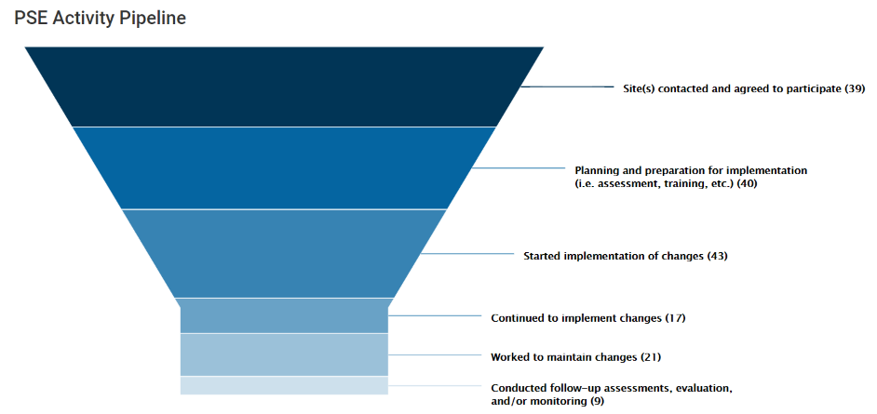

The PSE Activity Pipeline can be clipped from the PEARS Impact Dashboard. Filter for FFY2020 data and for individual counties or if preferred the entire cluster.

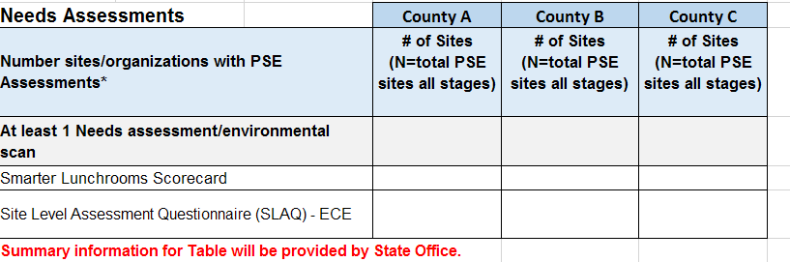

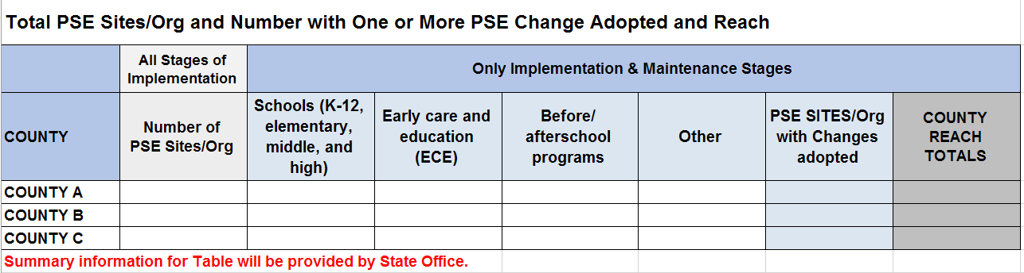

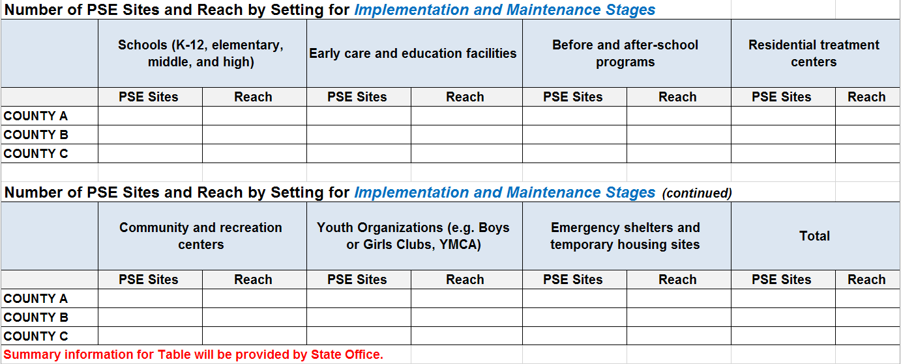

PSE Changes Adopted

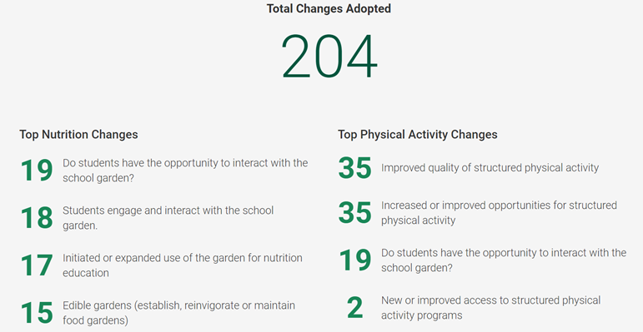

The PSE Changes Adopted (total and top 5 for Nutrition and Physical Activity) can be clipped from the Impact Dashboard. Filter for FFY2020 data and for individual counties.

1. Total Partners and Partners by Type and Number of Coalitions and Members by Sectors of Influence) – Tables to be provided by the State Office





# Success Stories, Challenges and Planned Improvements for FFY 2021

1. **Success – See PEARS Success Story entry**

From the PEARS Success Story Module, please provide the PEARS ID number and name of at least one success story if possible one per county. The State Office county contact will review and follow-up with questions as needed. Photos are terrific to include. But, a photo release needs to be on file for each identifiable participant.

1. **Responding to the COVID-19 Challenge**

**Describe how your program responded to COVID-19 challenges. What were the major areas of focus to adapt programming and build capacity to continue to contribute to CalFresh Healthy Living, University of California goals and objectives.**  **Suggested maximum length: 500 words**

1. **Optional Data to show COVID-19 Impact -** Tables to be provided by the State Office and can be incorporated if desired.



1. **Optional Describe any additional Challenge(s)**

Optional, describe any additional challenge(s) that were important during the year. **Suggested maximum length: 200 words**

1. **Planned Improvements**

Describe any modifications you plan to make in the next fiscal year to improve the effectiveness of your program based on program findings and feedback and/or to address problems experienced during the past year. **Suggested maximum length: 250 words**

# Presentations, Publications and Awards

1. **Conference Presentations and Posters, Publications**

Please list publications in the following sub-categories with links.

APA format is preferred for publications. Example: Last name, First name. (Year). Title. Publication. DOI or website link.

* Conference Presentations:
* Posters:
* UC Delivers Blogs:
* UC ANR Blogs (Food Blogs, Communities, etc):
* News coverage – Print and Electronic Media:
* News coverage - Broadcast Media:

1. **Awards Received**

Please list any external awards received. Do not include UCD or UC ANR internal staff awards. If none, note “N/A”. Ex: “Award Name” - Presented to Persona Fake - 2/2020